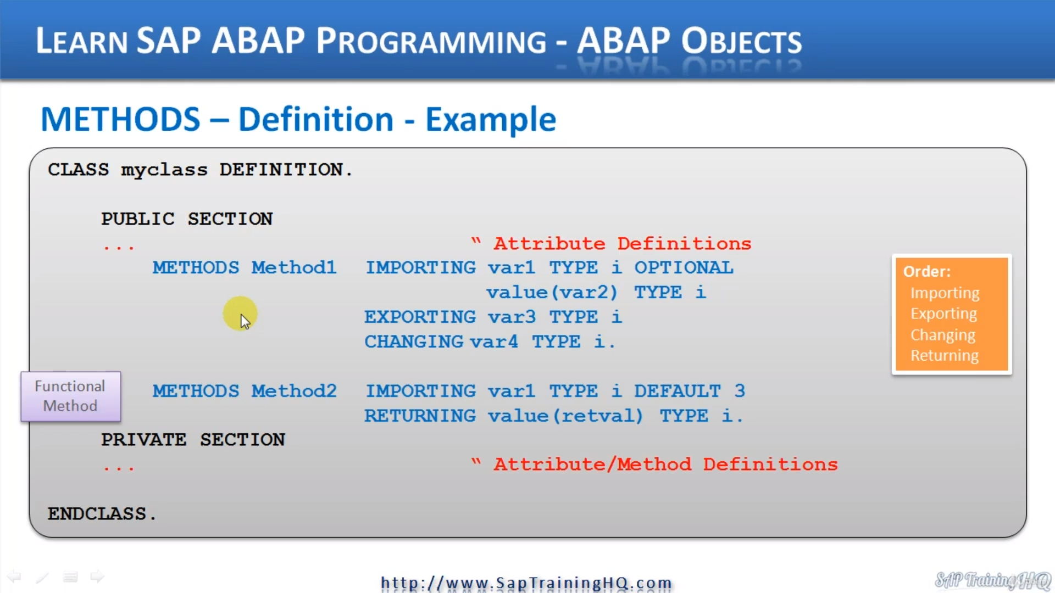

So, the first thing is to define methods, we use the methods keyword and then we give the method a name.

In this example, Method one will be importing data object var one. And I've declared this as an integer and made it optional.

So, this means the culling program does not have to pass enough value for this data object because we marked it is optional, but they can if they wish.

Then I've also declared a second data object named VAR2, and this time I'm using the pass by value option.

So, as you can see here, we have value. And then in brackets we specify that data object name. And again, I've declared this one as an integer.

And you can see I am declaring another data object called Var3, but this time this is going to be an exporting parameter, which means this is going to be a parameter that will be passed back to the calling program and again, update behind it as an integer.

Then the last data object here I've called var4. And just so we are covering all the bases here, this time I'm declaring it as changing and again with a type I.

So, Method one has four data objects with one of them designated as optional.

Two of the data objects are used to hold inbound data objects and one is used to hold outbound data

objects.

And finally, one is declared as changing, which means it's going to import one thing and likely get changed, which it will then export back to the calling program.

Now, let's have a look at Method2, and you can see this time I'm showing an example of a functional method and with a functional method, we are using a returning data object.

This method will import a data object into data object variable one vial, one that I have declared as an integer and have a given a default value of three and then the value stored in data object.

RetVal, which is also defined as an integer, will then be returned to the calling program.

REPORT ZYNY_CLASS.  
  
CLASS STUDENT DEFINITION.  
  PUBLIC SECTION.  
  DATA : NAME TYPE C LENGTH 40,  
        AGE TYPE I,  
        gender TYPE c LENGTH 1 READ-ONLY,  
        STATUS TYPE c LENGTH 1.  
*        GENDER TYPE C LENGTH 1 READ-ONLY VALUE 'U'.  
  
  CLASS-DATA: count TYPE i.  
  
  METHODS : setname IMPORTING NAMEIN TYPE C,  
            GETNAME EXPORTING NAMEOUT TYPE C,  
            SETSTATUS CHANGING NEWSTATUS TYPE C.  
  
  
  PRIVATE SECTION.  
  DATA :  LOGINID TYPE C LENGTH 20,  
        PWD TYPE C LENGTH 15.  
  ENDCLASS.

If we wanted to create private methods, all we would do is come down here and declare the methods in this section of our class.

So right here, this is where you would declare your private methods.